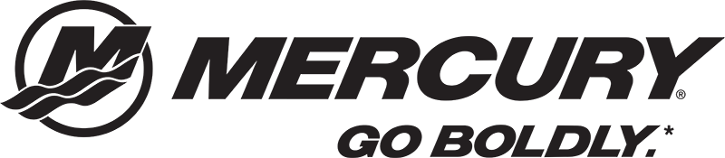

Mercury National Boat Demo Experience
Boating enthusiasts are invited to Oven Island (by the docks in the channel) during Walleye Weekend to take a boat demo ride. Whether you’re looking to repower your current boat, upgrade or buy a new rig, you won't want to miss this opportunity

Demo Times!!!
Friday June 7th - 3:30 pm - 7:00 pm Open Mercury National participants only. Demo’s will stop during the tournament meeting at 5:30pm and then reconvene until 7:00 pm
Saturday June 8th - 9 am - 1 pm - Open to the public
Sunday June 9th - 9 am - 1 pm - Open to the public
General Details

Demo's will take place at Oven Island (by the docks in the channel). Experienced drivers will conduct the demo rides and Mercury ambassadors will be on hand to assist with questions. All participants must sign a waiver release and life jackets will be provided and must always be worn while on the boats.

2019 Walleye Weekend Demo Boats
Dealer | Boat | Engine Power | Driver
Open | ZV21 | 350 Verado + 9 Kicker | Bill Hagge
Open | ZV20 | 300 V8 Pro XS | Multi
Merc National | ZV21 | 350 Verado + 15 Kicker | Keith K
All Out Marine | Targa 19 | 200 XL V8 Pro XS | Jack and Jacob
Sport O'Motive | ZV 19 Sport | 225 V8 Pro XS | BJ
MW Marine | Ranger 621FS | 350 Verado + 15 Kicker | Kevin Dahl
Cedar Lake | Bass Cat Caracal | 225 V8 Pro XS | Ivan
Cedar Lake | 219 Yar Craft | 350 Verado | Bob Clause
Wendts | 2075 Pro V ( Alum ) | 300 V8 Pro XS | Scott Klein
The Boat Doc | 216 Triton | 350 Verado | Sean Freund
The Boat Doc | 206 Triton Allure | 250 V8 Pro XS | Craig Suda
Mr. Marine | 208 Warrior | 300 V8 Verado | Tony Barber

